November Student Commitment
& Early Enrollment Form
The Bridge Program offers an advanced language pathway for high school students who have passed the Advanced Placement (AP) Language and Culture Exam, "bridging" the gap between completion of the exam and higher education.
Students begin upper division university language course work in the high school setting, where each 3-credit college course extends over a full academic year of high school. This rigorous and supportive environment establishes a university and career pathway in two languages, and seeks to promote access to bilingual, biliterate, and multicultural citizenship in Utah.

Why enroll in early college Language Bridge Program courses?
- By enrolling in a Bridge Course, you earn university credit PLUS high school credit which counts towards graduation. This is called Concurrent Enrollment (CE).

- Start earning credit towards a university major or minor in your language:  - Bridge Courses are upper division language courses, which allow you to jump past freshman college level courses and begin work towards a major or minor.  - Students who successfully complete all 3 Bridge Courses graduate from High School just 2-3 courses shy of a minor in their language of study. | - Growing up bilingual and bicultural:  - For students who grew up hearing, speaking, or studying in Chinese, this pathway promotes continued advancement of your heritage language and culture, preparing you to be citizens of a multilingual and multicultural world.  - For students learning Chinese as their second language, this pathway promotes understanding of advanced linguistic skills and cultural identity, readying you as citizens of a multilingual and multicultural world.
- Get paid more in future careers:  Students with advanced language proficiency in 2 languages are highly marketable for future employment opportunities. | - CE, early college credit is incredibly cheap!  If you were to wait and take this 3-credit course after you graduate from high school, you would pay $1,684.62 at the University of Utah. Because Utah wants students to be on a college-ready pathway, you get to earn the same credits while in high school for only $15. Congratulations on choosing an early college pathway!

Secondary Advanced Language Pathways
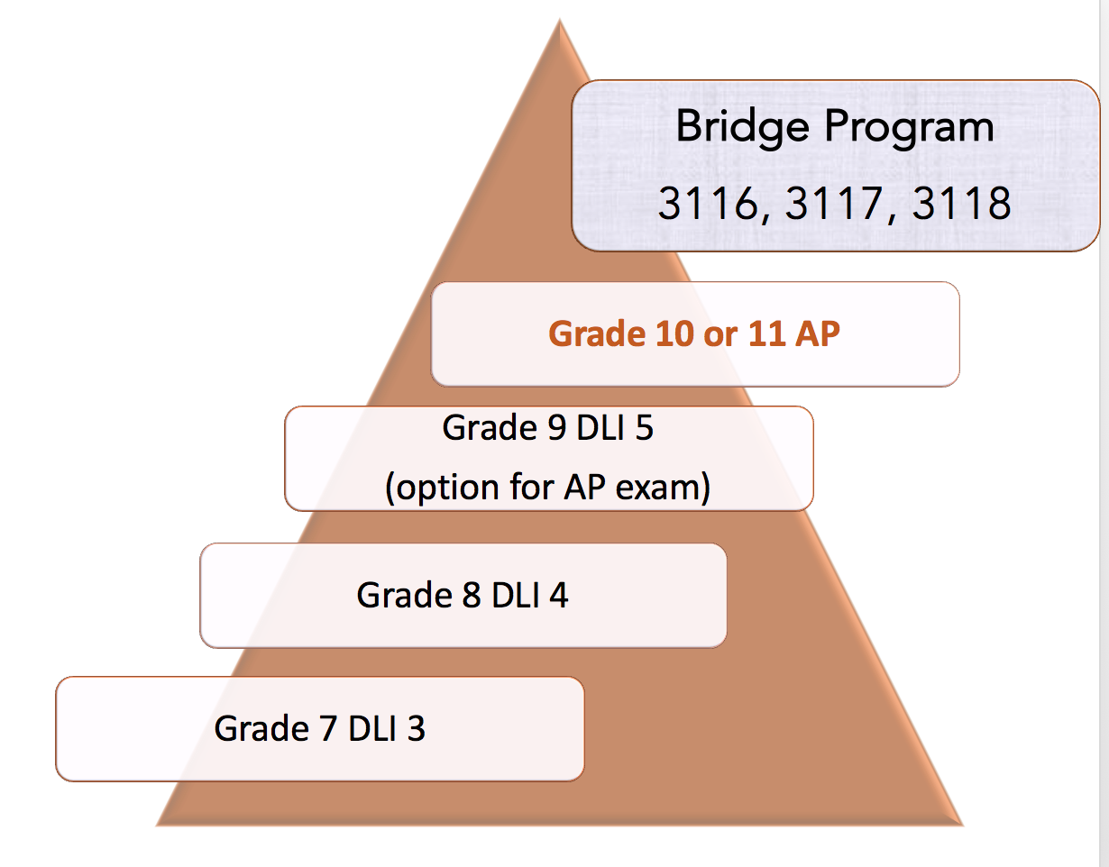
All students are encouraged to check their progress in academic language learning by taking the AP test in grade 9, if they wish.

If a student in grade 9 attempts the AP test and scores a 1 or 2, they progress to the next sequential course, AP Language.

If a student in grade 9 attempts the AP test and scores a 3 or higher, they are accelerated to the Bridge Program courses.

November Student Commitment
& Early Enrollment Form
Please complete this form in class and return to your instructor.

The Bridge Program is open to students in grades 10-12 who have received a 3 or higher in the AP Language and Culture exam prior to enrolling.
First Name: _________________________________________________________________
Last Name: _________________________________________________________________
Current grade level: __________
I plan to attend the following high school next year: ______________
Please select all that apply:
- I am currently enrolled in the DLI 5 class, plan to take the AP Language and Culture exam this spring, and commit to enroll in either AP Language or the Bridge course next year.
- I am currently enrolled in the AP Language and Culture class, plan to take the exam this spring, and commit to enroll in the Bridge course next year.
- I am currently enrolled in this year’s Bridge Program course and commit to enroll in the Bridge course next year.
Please circle one:
I DO / DO NOT intend and commit to enroll in the Bridge Course next academic year (pending AP Language and Culture test results)

